目录

1 Uniswap Fork Process 1

1 copy paste the original code 1

2 deploy smart contracts 1

3 modify the frontend 1

4 Uniswap Smart Contracts Deployment 1

5 Uniswap Frontend 2

2 Write a Store Factory Using Openzeppelin 3

1coding 3

2 Manual test 4

3 truffle test 4

# 1 Uniswap Fork Process

1 copy paste the original code

2 deploy smart contracts

3 modify the frontend

https://github.com/Uniswap/uniswap-v2-core

https://github.com/Uniswap/uniswap-v2-periphery

https://github.com/Uniswap/uniswap-interface

## 4 Uniswap Smart Contracts Deployment

https://github.com/Uniswap/uniswap-v2-core

Factory = market, creating pairs, setting fees

install nodejs and truffle

npm install -g truffle

mkdir core

cd core

truffle init

cp -r ../uniswap-v2-core/contracts/* contracts

tell truffle how to deply the contracts

create your test tokens

npm init -y

npm install @openzeppelin/contracts@2.5.1

Writing the migration file

Setting up the deployment address with gas in it in truffle.config

npm install @truffle/hdwallet-provider

obtain your infura rpc access

truffle deploy --network ropsten

https://github.com/Uniswap/uniswap-v2-periphery

truffle init

cp -r ../uniswap-v2-periphery-master/contracts/* contracts

npm install @uniswap/lib @uniswap/v2-core

https://etherscan.io/address/0xc02aaa39b223fe8d0a0e5c4f27ead9083c756cc2#code

get wrapped ether

Change solidity 0.4 -> 0.6

## 5 Uniswap Frontend

https://github.com/Uniswap/uniswap-interface

follow its instructions

git clone https://github.com/Uniswap/uniswap-interface.git or Download the copy

yarn

yarn start

why? let's take a look at it package.json file

it acturally iinstalls all the dependencies and runs “react-scripts start”

replace the contract address

https://github.com/Uniswap/uniswap-interface/blob/c5afbedb3e3d500426f8ebe5d06fca993a7bbd22/src/constants/index.ts

Search for ‘0x’

# 2 Write a Store Factory Using Openzeppelin

Github.com/onebit256/proxy

## 1coding

Ganache-cli -m ‘’

Truffle init

Npm init

Npm i @openzeppelin/upgrades@2.8.0

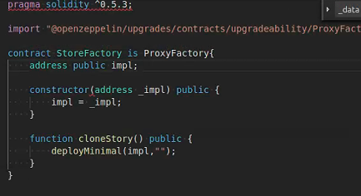

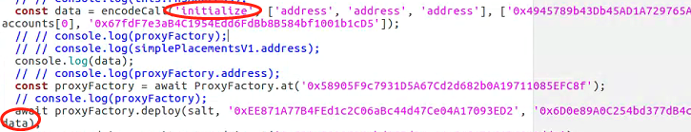

As there is no init function

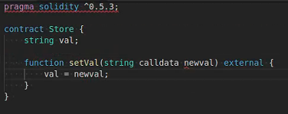

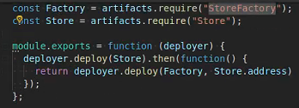

## 2 Manual test

Const sf = await StoreFactory.deployed()

Sf.impl()

Networks

Sf.clonestore()

Sf.getPastEvents()

Sf.clonestore()

Sf.clonestore()

St1 = Store.at(‘’)

St1.setVal(“ss”)

St1.val()

## 3 truffle test